***Software Testing Assignment***

***Module -1 (fundamental)***

1. what is SDLC

Ans. SDLC is a process of development .its defines the process for planning ,implementation ,,testing ,documentation ,deployment ongoing maintenance and support for software product .

2. What is software testing ?

Ans.- software testing is a process of identify the correctness, completeness, and quality of developed computer software .

3. What is agile methodology ?

Ans.: Agile methodology is a combination of iterative and incremental which focus on adaptability and customer satisfaction and rapid delivery of working software product .

Agile methodology heavily depends on customer side

4. What is SRS

Ans. A software requirement specification (SRS) is a document that describe what the software will do and how it will be expected to perform . It also describe the functionality the product needs to fulfill the needs of all stakeholders .

5 What is oops .

Ans. : Object oriented program is computer programming based on the concept of object which contain data and code .

An object can be defined as a data field that has unique attributes and behavior.

6. Write basic concept of oops.

Ans. : There are 6 basic concepts of oops

1.Object

2.Class

3.Encapsulation

4.Inheritance

5.Polymorphism

6.Abstraction

6.what is object ?

Ans. .object means a real world entity such as a pen chair table computer etc.

7.what is class

Ans. .class works as a blue print for an object .

E.g. Apple is fruit

Apple is object and fruit is class .

8. what is encapsulation

Ans. Wrapping up of data into a single unit is called encapsulation

9. What is inheritance

Ans. Ability to adapt the behavior of parent class into the child class is called inheritance .

10.What is polymorphism

Ans. -Ability to react in different way is called polymorphism.

11. draw use case on online book shopping .

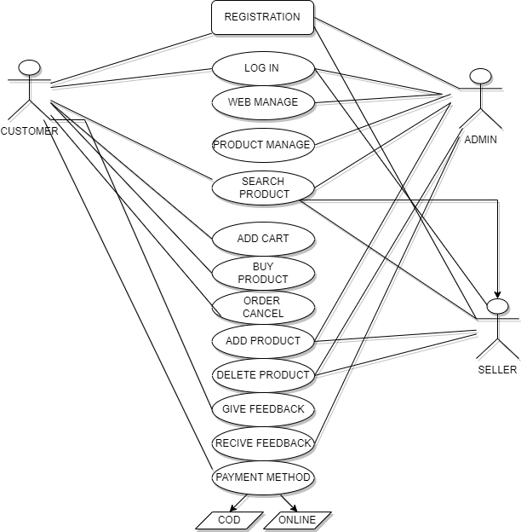

12.Write SDLC phases with basic introduction

Ans. : There are 6 phases in in SDLC

1.Requirement gathering : first of all, project manager gathers the requirement from client and establish customer need in this phase

There are two type of requirement

1 functional requirement

2 Non – functional requirement

2.Analysis : analysis phase defines the problem that the customer is trying to solve and specify the customer needs

3. Design : Then designer (software architecture )make design as per the requirement

4. Implementation : In the implementation phase , the team builds the components either from scratch or by composition

And developer does code as per the design

5. Testing : Testing Phase is separate phase which is performed by a different team (QA team ) after the implementation is completed

Then QA will test the application .Once QA will approve the app then it will be sent to the client .

6. maintenance : maintenance is the process of changing a system after it has been deployed .

Process of repair defect and adapt the solution of new requirement

There are three type of maintenance

Corrective maintenance

Adaptive maintenance

Perfective maintenance

13. Explain phases of waterfall model

Ans.: It is called the classical and traditional software life cycle model .Waterfall model is inherited from SDLC .

In water fall model ,we have to go step by step from top to bottom of the SLDC phases.

If we are on stage of testing and we find the defect in designing then we can’t move on designing directly , we have to restart the process from requirement gathering . it will become long process .

14. Write phases of spiral model.

Ans. :Spiral model is very widely uses in the software industry as it it synch with the natural development process of any product

There are four phases in spiral model

1 Planning : The first phase of the spiral model is planning phase, this phase include requirement gathering and analysis . and plan created for the next iteration of the spiral .

2. Risk analysis : In the risk analysis phase , the risks associated with the project are identified and evaluation .

3. Engineering : In the engineering phase, the software is developed based on the requirement .

4. Evaluation: In this evaluation phase , the software is evaluate to determine if it meets the customer `s requirement

15. Write agile manifesto principles .

Ans. : There are 4 manifesto principles of Agile

1. Individuals and interaction

2. Working software

3. Customer collaboration

4. Responding to change

16. Explain working methodology of agile model and also write pros and cons.

Ans. : Agile methodology is a combination of iterative and incremental which focus on adaptability and customer Satisfaction and rapid delivery of working software product .

*Agile method heavily depends on customer side.

*In agile we break the product into smaller incremental builds or iteration .

*In agile we are not following particular document or process but we work as the customer tells us .

*The time spends on each iteration is 1 to 3 weeks while working in agile we need to make sure about deadlines .

*After the end of iteration we display the working model to customer and if there any changes of any new requirement we will get solved by next iteration .

Pros :

* Easy to manage
* Little or no planning required
* It is very realistic approach to software development
* Promotes team work
* Minimal rules , documentation easily employed .

Cons :

* Depends heavily on customers side if customer is not clear ,team can be driven in the wrong direction .
* Not suitable for handling complex dependencies .
* There are more risk of maintainability ,sustainability .
* Transfer of technology to new team members may be quite challenging due to lack of documentation .

17. Draw use case on online product shopping using COD

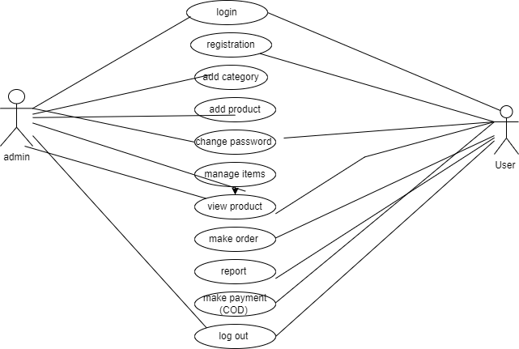

18. draw use case on online shopping shopping product using payment gateway .

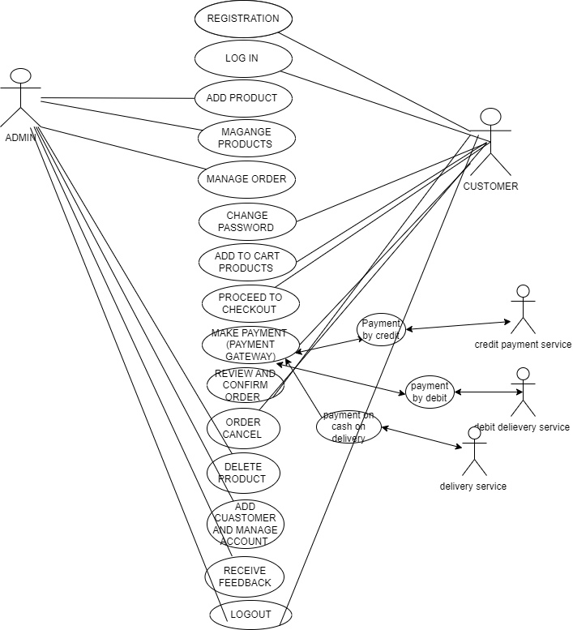

19.Draw use case on online bill payment system (paytm).

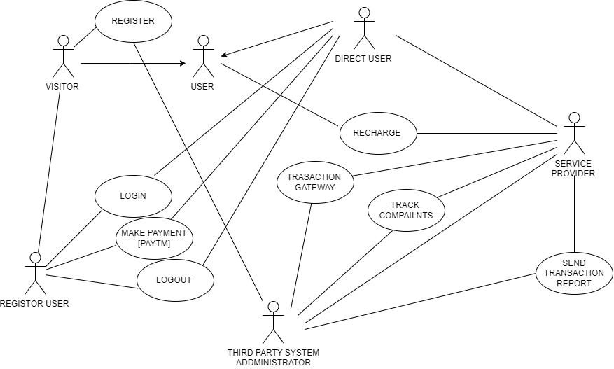

20. Draw use case on food application with COD .

